List of interviewers for the employment sample survey

Last name, first name, patronymic of the interviewer |  | Surveyed locality
Karman Anara Bekbolatovna |  | c.а. Pavlodara
Baisova Dinara Bektasovna |  | c.а. Pavlodara
Baybusunova  Gulnar Abdykarimovna |  | c.а. Aksu
Kaiyrbekkyzy  Gulzhanat | 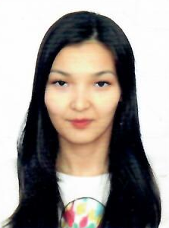 | c.а. Ekibastuz
Zeinullina  Meruert  Maratovna | 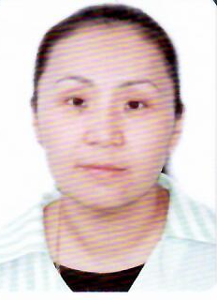 | c.а. Ekibastuz
Abdygalieva  Nargul Mubarakovna | 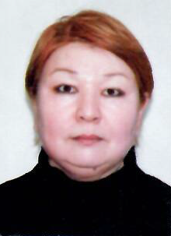 | Aktogay district
Rakhimova  Saule Bulatovna |  | Bayanaul district
Komnik  Victoria Sergeevna |  | Zhelezinsky district
Ignasheva  Anna Aleksandrovna |  | Zhelezinsky district
Idrisova  Nazgul Zhanatalyapovna |  | Irtysh district
Kazhimova  Erkesh Bektasovna |  | Irtysh district
Turguldinova  Akbota Khabibolovna |  | Terenkol district
Urtakova  Marina Temirzhanovna |  | Terenkol district
Sagnaeva  Ardak Shaimardanovna |  | Akkuly district
Omarov  Darkhan Serikkalievich | 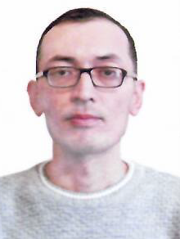 | Maysky district
Zefirova  Oksana Alexandrovna | 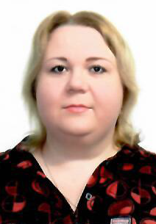 | Pavlodar district
Bobrova  Nadezhda Alexandrovna |  | Pavlodar district
Donets  Zarina Ablaikanovna |  | Uspensky district
Zhangazinova  Zaure Kairzhanovna |  | Uspensky district
Movilo  Olga Sergeevna |  | Shcherbakty district

